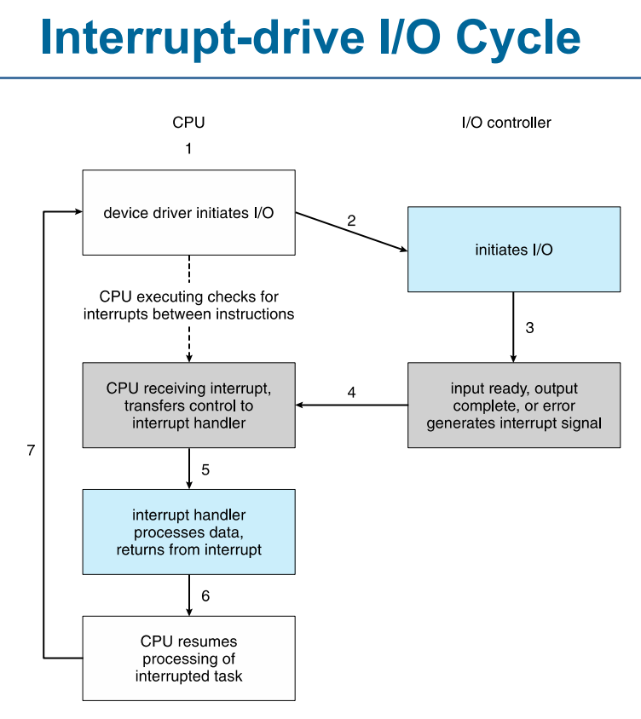

**Synchronous vs. Asynchronous I/O Handling**

**1. Synchronous I/O**

* In **synchronous I/O**, the **CPU waits** for the I/O operation to complete before continuing execution.
* The process making the request is **blocked** until the operation is finished.
* The CPU is **idle** during the I/O process, reducing efficiency.

**Example:**

* Reading a file where the program **pauses execution** until all data is read.
* A user enters input in a terminal, and the program waits before proceeding.

**2. Asynchronous I/O**

* In **asynchronous I/O**, the **CPU continues execution** without waiting for the I/O operation to finish.
* The I/O operation is handled **in the background**, and the CPU performs other tasks.
* The OS **notifies** the process when the I/O operation is done (via interrupts or callbacks).

**Example:**

* A web server handling multiple requests simultaneously.
* Reading a large file while performing other computations.

**System Daemons**

A system daemon is a computer program that runs in the background to perform tasks without user input. They are typically started at system boot and continue running in the background, handling tasks like logging, networking, scheduling, and device management.

**System Timer**

A **timer** (or **system timer**) in an operating system is a hardware component that generates periodic interrupts to help the OS manage time-dependent tasks. It plays a crucial role in **process scheduling**, **resource allocation**, and **performance monitoring**.

**Functions of a Timer in OS**

1. **Process Scheduling**
   * Ensures fair CPU time allocation by enforcing **time-sharing** in multitasking systems.
   * Triggers **context switching** when a process's time slice expires.
2. **Prevention of Infinite Loops**
   * Prevents a process from monopolizing the CPU by setting a time limit for execution.
   * If the time limit expires, the OS forcibly switches to another process.
3. **Synchronizing System Operations**
   * Helps in periodic operations such as checking system health, updating logs, or refreshing caches.
4. **Timeout Handling**
   * Used for handling I/O operations and network communication timeouts.
   * Example: If a process waits too long for an input, the OS can free the resource.
5. **Performance Monitoring**
   * Helps track CPU usage and collect system performance metrics.

**Responsibilities of I/O Subsystem:**

**1. Memory Management of I/O**

Since I/O operations are much slower than CPU execution, the OS uses various techniques to optimize data transfers:

* **Buffering:**
  + Temporarily stores data while transferring between devices and applications.
  + Ensures smooth data flow between devices with different speeds (e.g., reading from a slow hard disk and transferring to fast RAM).
  + Example: When watching a YouTube video, buffering loads a few seconds of video in advance.
* **Caching:**
  + Stores frequently accessed data in a faster storage area for quick retrieval.
  + Reduces redundant I/O operations and improves performance.
  + Example: Web browsers cache frequently visited pages, so they load faster.
* **Spooling (Simultaneous Peripheral Operation On-Line):**
  + Allows multiple processes to use the same I/O device by queuing up tasks.
  + Useful for devices like printers, where multiple print jobs are queued and executed one by one.
  + Example: In a shared office printer, multiple print requests are stored in a spooler queue before being printed one at a time.

**Virtualization**

It allows multiple operating systems and applications to run on the same physical hardware, improving efficiency, resource utilization, and flexibility.

**Hardware Virtualization**

* Uses a **hypervisor (Virtual Machine Manager - VMM)** to create multiple virtual machines (VMs) on a single physical machine.
* Each VM runs its own operating system with its own kernel, independent of others.
* **Examples:** VMware, VirtualBox, Microsoft Hyper-V.

**OS-Level Virtualization (Containerization)**

* Instead of virtualizing hardware, this method **virtualizes the OS kernel**, allowing multiple isolated user-space instances (containers).
* Unlike VMs, containers share the host OS kernel but run separately.
* **Examples:** Docker, Kubernetes, LXC (Linux Containers).

**Real-World Applications of Virtualization**

* 🏢 Cloud Computing: AWS, Azure, and Google Cloud use virtualization to provide scalable computing resources.
* 🎮 Gaming: Cloud gaming platforms like NVIDIA GeForce Now use virtualization to stream games.
* 📡 Telecommunications: Virtualized network functions (NFV) improve service delivery.
* 💻 Software Development: Developers use VMs to test applications in multiple OS environments.

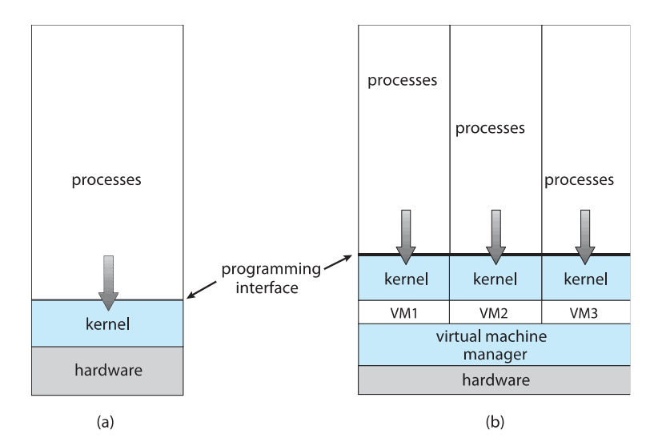

**Cache in Single-Core vs. Dual-Core Processors**

1. **Single-Core Processor Cache:**
   * Has **one** core, so all **L1, L2, and possibly L3 cache** are dedicated to that single core.
   * Since only one process runs at a time, cache contention is minimal.
   * Performance is limited by the single-core processing speed.
2. **Dual-Core Processor Cache:**
   * Each core has its **own L1 cache** (separate for each core).
   * L2 cache may be **shared** between cores or **dedicated** per core, depending on the processor design.
   * If there’s an **L3 cache**, it is usually **shared** between both cores to improve communication and efficiency.
   * Helps in faster task switching and **parallel execution** of processes.

**Non-Uniform Memory Access (NUMA) System**

**Non-Uniform Memory Access (NUMA)** is a computer memory architecture used in **multiprocessor** systems, where memory access **time depends on the location** of the memory relative to a processor.

**Key Concepts of NUMA:**

1. **Distributed Memory Architecture:**
   * Memory is physically divided into multiple regions, each associated with a specific processor.
   * Processors can access their **local memory** faster than **remote memory**.
2. **Processor Affinity:**
   * To minimize latency, tasks are scheduled to run on processors that are closer to the memory they frequently access.
3. **NUMA Nodes:**
   * The system is divided into **nodes**, where each node consists of one or more processors and a portion of the total memory.
4. **Memory Access Speed:**
   * **Local memory** (attached to the processor) is accessed faster.
   * **Remote memory** (belonging to other processors) has higher latency.

**NUMA UMA**

